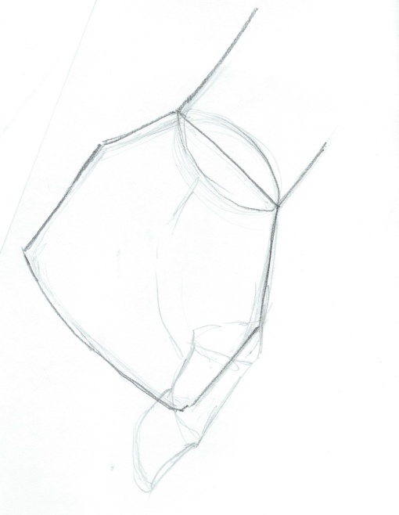

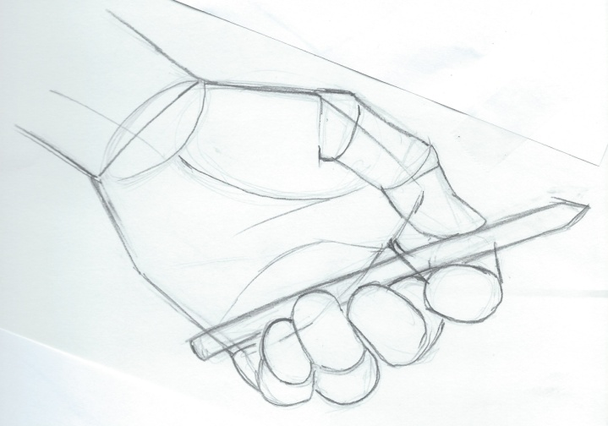

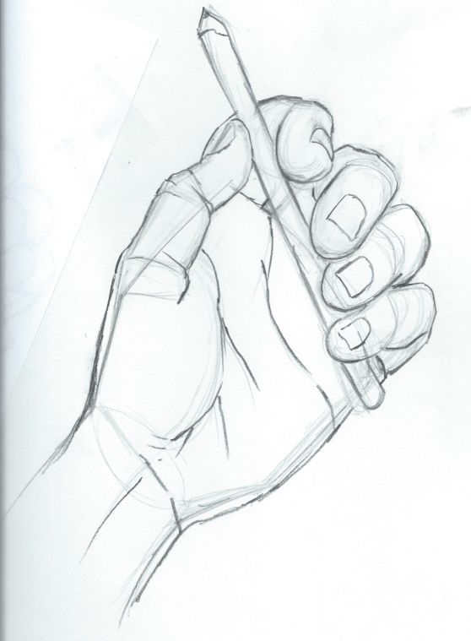
1. Draw with light lines.
2. Draw a trapezoidal shape for the palm of the hand and a couple of lines for the wrist.
3. Add the basic oval like shapes of the fingers. Do not add details at this point.
Tips: It is okay to draw the shapes as if they are see through.
Watch where fingers overlap when they are holding things. The pads in your fingers bunch when they are squeezed.

4. When your drawing is correct, add details like wrinkles, folds, and fingernails.

