Guided Notes on One Point Linear Perspective Drawing
- During the _________________________________ artists became interested in making _____________-dimensional artwork look ___________________-dimensional.
- Some ways to help create the illusion of space on a two dimensional surface:
- _________________________________________________
- _________________________________________________
- Objects that are closer are _____________________________.
- Objects that are farther away are _________________________.
- Objects that are closer are ________________________________________________________.
- Objects that are farther away are __________________________________________________.
- Everything appears to recede into the distance at the same rate, ________________________, or coming together, at a ______________________________ on the _____________________.
- Artists used mathematics and close observation to invent _______________________________.
Linear perspective allows artists to trick the eye into seeing depth on a flat surface.
- To create the _______________________ of space, the artist creates a _____________________________ on the _______________________________________.
- Objects are drawn using _____________________________________, which lead to the ________________________________________.
- _______________________________________________________: A version of linear perspective in which there is only one vanishing point in the composition.
- _____________________________________ the canvas or piece of paper the painting or drawing is on
- __________________________________: represents the viewer’s eye level
- __________________________________________: (aka vanishing lines) two or more imaginary lines that get closer and closer towards the vanishing point. Used to create accurate linear perspective.
- ___________________________________________: the point in linear perspective at which all converging lines of perspective meet.
- 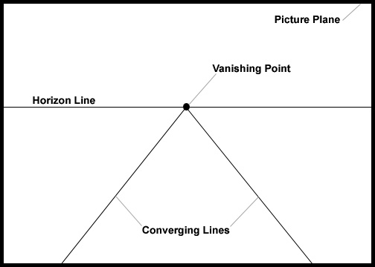
In the box below draw a horizon line and a vanishing point on the horizon line. You will then draw three cubes one above, one below, and one overlapping the horizon line. You will need a ruler and a pencil to complete this.

Thumbnail Sketches
In the boxes below, do three sketches to prepare yourself for your final piece. In the spaces provided experiment with different ideas, compositions, subject matter, and themes.

