1. Hold your pencil loosely and don't "write" your drawing.
2. Start out with light lines
3. Draw the outline of the major shapes paying close attention to angles and curves
4. As you draw pay attention to how different parts line up.
5. Do your best to draw what you see not what you "know".
6. Early on do not add too many details.
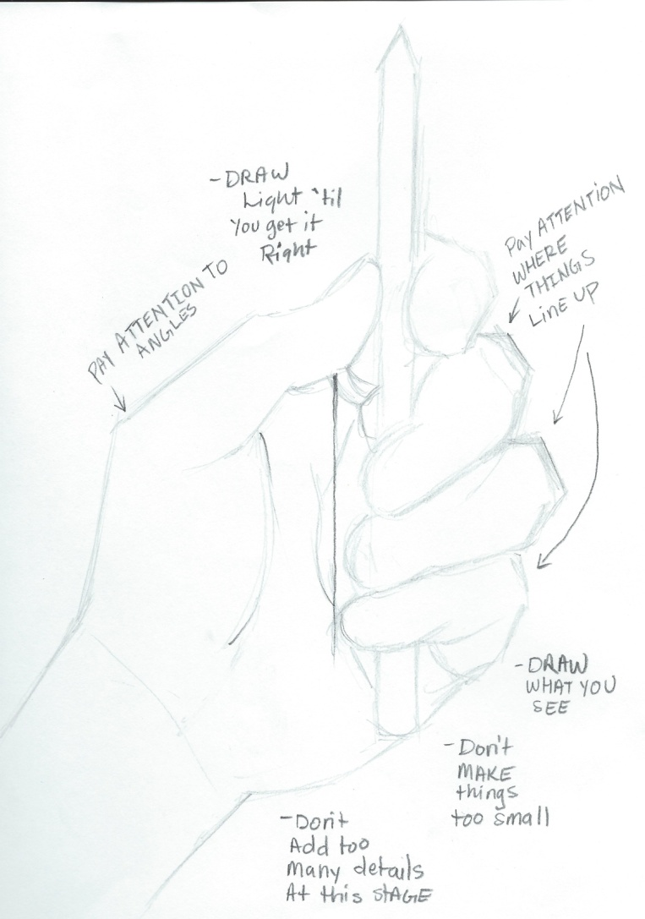
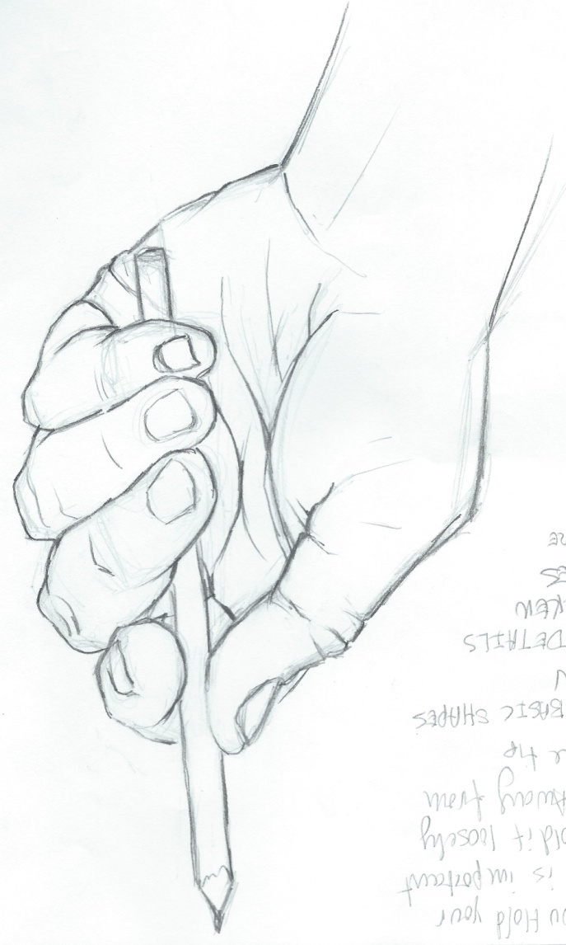
7. When you have everything sketched out lightly in pencil, then add details like wrinkles, folds, and fingernails.

