Color Wheel Notes
Write in the missing colors of the color wheel: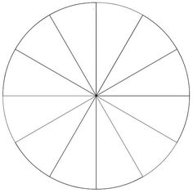
Primary colors are _________________ __________________ from other elements and they _____________________________ ____________ _________________ ________________________.
The Primary Colors Are: ____________________, _______________________, and _______________.
By _________________________ _____________ _____________________ colors, a secondary color is created.
The Secondary Colors are:
Red + Blue =
Yellow + Blue =
Red + Yellow =

Tertiary, or intermediate, colors are created by ________________________________ ___ ___________________________ ___________ _____ __________________________________color.
The Tertiary colors are:
1.
2.
3.
4.
5.
6.
Complementary Colors are on _____________________________ ____________ ________ ________ __________________________ ________________________.
Write in the complement of each color listed below
Red –
Yellow –
Orange –
Blue- Green –
Red-Violet –
Blue-Violet -

