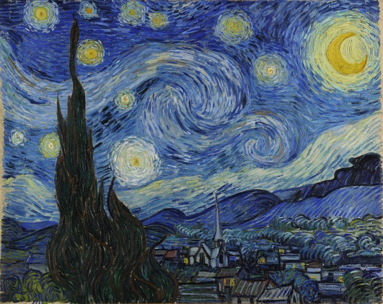
10th Grade Cambridge Art and Design Supply List
Required Supplies Needed Daily:
- Erasers (kneaded eraser, soft white or pink eraser)
- Drawing pencil set (2H, HB, 2B, 4B, 6B) with storage container or bag
- Bound sketchbook (No Smaller than 8” x 10” and no larger than 11” x 14”)
- Dedicated two pocket folder for art class

Recommended Materials (Not Required):
- Pencil sharpener
- Digital camera or camera phone
- Color pencil set
- Marker set
- Set of painting supplies
- Set of Ink Pens
- Artist’s Smock, Apron, or Oversized T-shirt (This can be stored in the Art Room)

If you have any questions or concerns about the supply list, please don’t hesitate to contact me, Mr. Bauer, at dan.bauer@sp.imagineprep.com.

