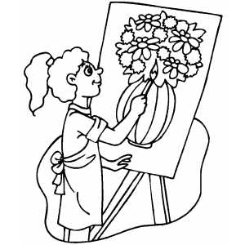
7th and 8th Grade Art Class Supply List
Required Supplies Needed Daily:
- 2 sharped pencils
- Large Pink or White Eraser
- Sketchbook (No Larger than 9”x12” and no smaller than 8”x10”)
- Black Ultra-Fine Point Sharpie
- Dedicated Two Pocket Folder for Art Class

Recommended Materials (Not Required):
- Pencil Sharpener
- Scissors
- Colored Pencils
- Markers
- Artist’s Smock, Apron, or Large T-Shirt (these can be stored in the art room)

